Java Assignment – 3
Name – Saideep Patil
Roll no - 49

1. Find the Sum all values in an array.

public class ArraySum {
public static void main(String[] args) { int[] numbers = {10, 20, 30, 40, 50}; int sum = 0;
for (int i = 0; i < numbers.length; i++) { sum += numbers[i];
}
System.out.println("Sum of all values in the array: " + sum);
}
}
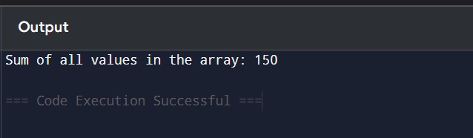

2.Find the Common elements in two string arrays.
public class CommonElements {
public static void main(String[] args) {
String[] arr1 = {"apple", "banana", "cherry", "mango"};
String[] arr2 = {"grape", "banana", "mango", "orange"};
HashSet<String> set1 = new HashSet(); HashSet<String> common = new HashSet(); for (String item : arr1) { set1.add(item);
}
for (String item : arr2)
{
if (set1.contains(item))
{
common.add(item);
}
}
System.out.println("Common elements: " + common);
}
}
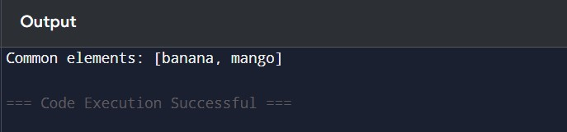
Q.3 Find out the Transpose of given Array.

public class TransposeMatrix { public static void main(String[] args) {
int[][] matrix = {
{1, 2, 3},
{4, 5, 6}
}
int rows = matrix.length; int cols = matrix[0].length; int[][] transpose = new int[cols][rows]; for (int i = 0; i < rows; i++) { for (int j = 0; j < cols; j++) {
transpose[j][i] = matrix[i][j];
}
}
System.out.println("Transpose of the matrix:");
for (int i = 0; i < cols; i++) { for (int j = 0; j < rows; j++) {
System.out.print(transpose[i][j] + " ");
}
System.out.println();
}
}
}

